**Assignment 4**

**Name: RAMAVATH SANTHOSH**

**ROLL NO: 22MCF1R40**

**2ND SEMESTER, 1ST YEAR, MCA**

**\*\*\*\*\*\*\*\*\*\*\*\*\*\*\*\*\*\*\*\*\*\*\*\*\*\*\*\*\*\*\*\*\*\*\*\*\*\*\*\*\*\*\*\*\*\*\*\***

**1. Write a Servlet program to demonstrate Generic servlet.**

**Code**

**.html**

<a href="./hello"> Generic Servlet</a>

# .java

|  |
| --- |
| import java.io.*;  import javax.servlet.*;  public class First extends GenericServlet {  public void service(ServletRequest req, ServletResponse res) throws IOException, ServletException {    res.setContentType("text/html");    PrintWriter out = res.getWriter(); out.print("<html><body>"); out.print("<h1>hello generic servlet</h1>"); out.print("</body></html>");    }  } |

# .xml

<web-app>

<servlet>

<servlet-name>s1</servlet-name>

<servlet-class>First</servlet-class>

</servlet>

<servlet-mapping>

<servlet-name>s1</servlet-name>

<url-pattern>/hello</url-pattern>

</servlet-mapping>

</web-app>

**O**

**utput**

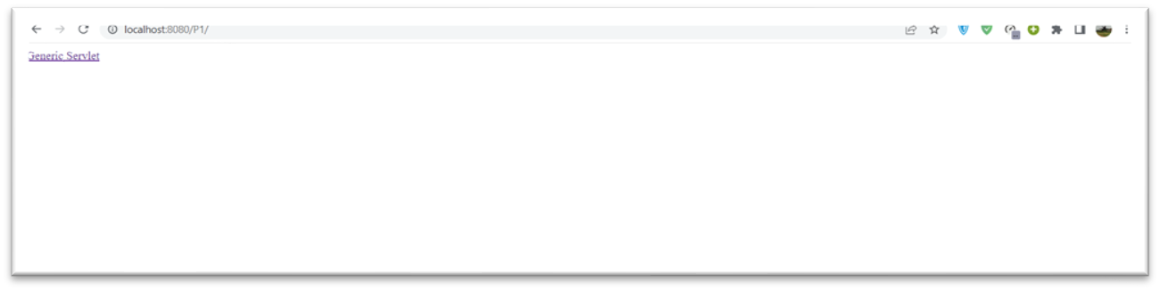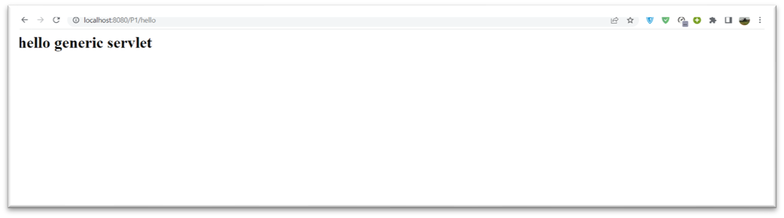

**2. Write a Servlet program to demonstrate HTTP servlet. Code**

# .java

|  |
| --- |
| import javax.servlet.http.*; import javax.servlet.*; import java.io.*;  public class DemoServlet extends HttpServlet{  public void doGet(HttpServletRequest req,HttpServletResponse res) throws ServletException,IOException  { res.setContentType("text/html");//setting the content type  PrintWriter pw=res.getWriter();//get the stream to write the data  pw.println("<html><body>"); //writing html in the stream  pw.println("Welcome to servlet"); pw.println("</body></html>"); pw.close();//closing the stream  } } |

# .xml

<web-app>

<servlet>

<servlet-name>s1</servlet-name>

<servlet-class>DemoServlet</servlet-class>

</servlet>

<servlet-mapping>

<servlet-name>s1</servlet-name>

<url-pattern>/httpServlet</url-pattern>

</servlet-mapping>

</web-app>

**O**

**utput**

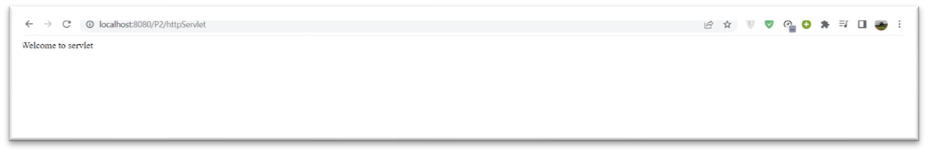

**3. Display your name using Servlet.**

**Code**

# .java

|  |
| --- |
| import javax.servlet.http.*; import javax.servlet.*; import java.io.*;  public class name extends HttpServlet{  public void doGet(HttpServletRequest req,HttpServletResponse res) throws ServletException,IOException  { res.setContentType("text/html");//setting the content type  PrintWriter pw=res.getWriter();//get the stream to write the data  pw.println("<html><body>"); //writing html in the stream  pw.println("Welcome Aman...!"); pw.println("</body></html>"); pw.close();//closing the stream  } } |

# .xml

<web-app>

<servlet>

<servlet-name>s1</servlet-name>

<servlet-class>name</servlet-class>

</servlet>

<servlet-mapping>

<servlet-name>s1</servlet-name>

<url-pattern>/display</url-pattern>

</servlet-mapping>

</web-app>

**O**

**utput**

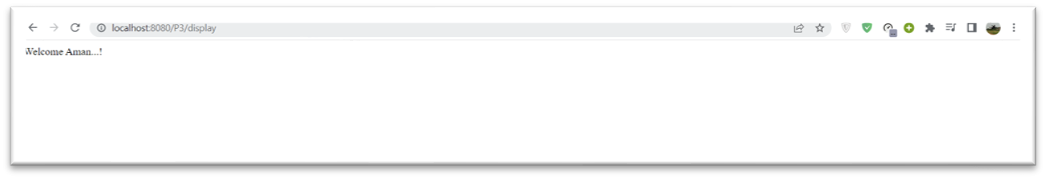

**4. Write Servlet program that takes your name, roll no and address from an HTML**

**Form and displays it.**

**Code**

# .html

<html>

<body> <form action="./details" method="POST">

Enter Name:<input type="text" name="name"/><br>

Enter Rollno:<input type="text" name="roll"/><br>

Enter Address:<input type="text" name="addrr"/><br>

<input type="submit" value="Submit"/>

</form>

</body>

</html>

# .java

import javax.servlet.http.*;

import javax.servlet.*;

import java.io.*;

public class details extends HttpServlet{ public void doPost(HttpServletRequest req,HttpServletResponse res) throws ServletException,IOException { res.setContentType("text/html");//setting the content type

PrintWriter pw=res.getWriter();//get the stream to write the data

String nme = req.getParameter("name");

String rlno = req.getParameter("roll"); String add = req.getParameter("addrr");

pw.println("<html><body>"); //writing html in the stream  pw.println("Name:"+ nme); pw.println("<br>");

pw.println("Roll no:"+ rlno); pw.println("<br>");

pw.println("\nAddresss:"+ add); pw.println("<br>");

pw.println("</body></html>"); pw.close();//closing the stream

} }

# .xml

<web-app>

<servlet>

<servlet-name>s1</servlet-name>

<servlet-class>details</servlet-class>

</servlet>

<servlet-mapping>

<servlet-name>s1</servlet-name>

<url-pattern>/details</url-pattern>

</servlet-mapping>

</web-app>

# Output

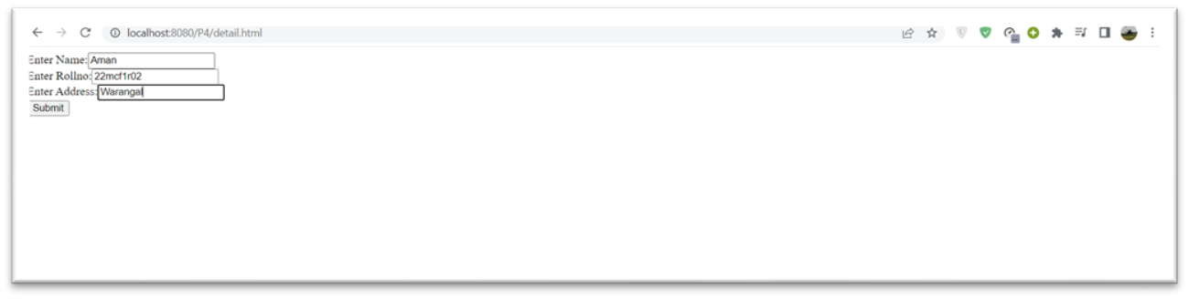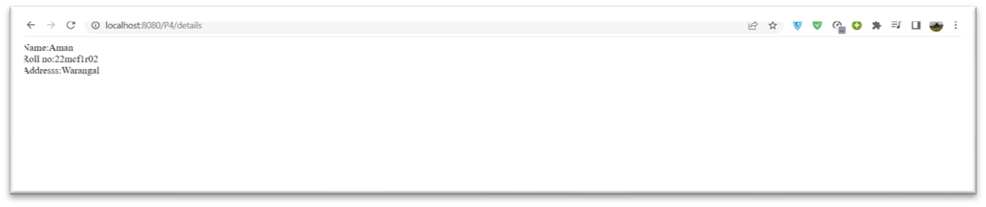

**5. Write Servlet program to read two numbers and return their sum.**

**Code**

# .html

<html>

<body> <form action="./First">

Enter n1 Value:<input type="text" name="t1"/><br>

Enter n2 Value:<input type="text" name="t2"/><br>

<input type="submit" value="click me"/>

</form>

</body>

</html>

# .java

|  |
| --- |
| import java.io.IOException; import javax.servlet.GenericServlet; import javax.servlet.ServletException; import javax.servlet.ServletRequest; import javax.servlet.ServletResponse;  public class First extends GenericServlet { |

public void service(ServletRequest request, ServletResponse response)

|  |
| --- |
| throws ServletException, IOException {  int a=Integer.parseInt(request.getParameter("t1")); int b=Integer.parseInt(request.getParameter("t2")); int c=a+b;  response.getWriter().print("Sum="+c); }    } |

# .xml

<web-app>

<welcome-file-list>

<welcome-file>index.html</welcome-file>

</welcome-file-list>

<servlet>

<servlet-name>First</servlet-name>

<servlet-class>First</servlet-class>

</servlet>

<servlet-mapping>

<servlet-name>First</servlet-name>

<url-pattern>/First</url-pattern>

</servlet-mapping>

</web-app>

**O**

**utput**

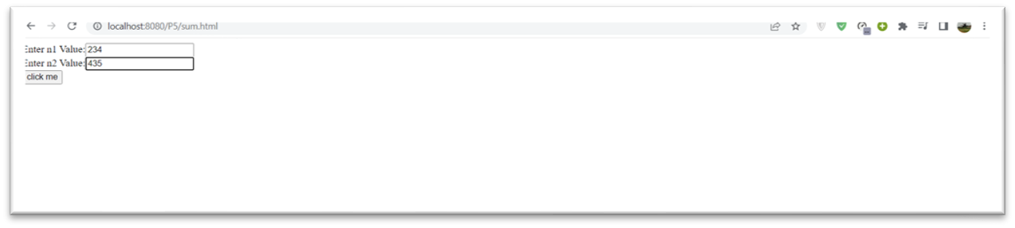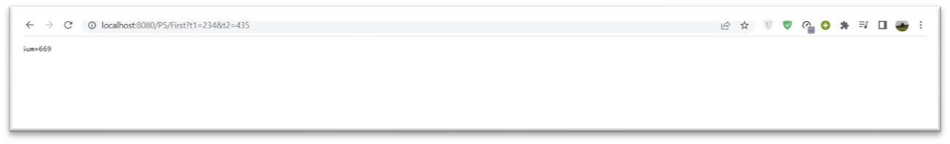

**6. Write a Servlet program to demonstrate Cookies.**

**Code**

# .html

<html>

<body>

<center>

<form action="addCookie"><pre>

<br><br><br><br><br>

Name:<input type="text" name="cname"/><br><br>

Value:<input type="text" name="cvalue"/><br>

<input type="submit" value="AddCookie"/>

</pre>

</form>

</center>

</body>

</html>

**.java**

# Addcookies

|  |
| --- |
| import javax.servlet.http.*; import javax.servlet.*; import java.io.*;  public class AddCookieServlet extends HttpServlet  { public void service(HttpServletRequest req,HttpServletResponse res)throws ServletException,IOException  { String name=req.getParameter("cname");  String value=req.getParameter("cvalue"); Cookie c=new Cookie(name,value); res.addCookie(c);  res.setContentType("text/html"); PrintWriter out=res.getWriter();  String output="<html><body>"; |

output+="Cookie Added Successfully <br/>";

output+="<a href='viewcookies'>View Cookies</a>"; output+="</body></html>"; out.println(output);

}

}

# Getcookies

|  |
| --- |
| import javax.servlet.http.*; import javax.servlet.*; import java.io.*;  public class GetCookieServlet extends HttpServlet  { public void service(HttpServletRequest req,HttpServletResponse res)throws ServletException,IOException  { res.setContentType("text/html"); PrintWriter out=res.getWriter(); out.println("<html><body><table border=1>");  out.println("<tr><th>Name</th><th>Value</th></tr>"); Cookie []c=req.getCookies(); if(c!=null)  { for(int i=0;i<c.length;i++)  { out.println("<tr><td>"+c[i].getName()+"</td>"); out.println("<td>"+c[i].getValue()+"</td></tr>");  }  } out.println("</table><br><br>"); out.println("</body></html>");  }  } |

# .xml

<?xml version="1.0"?>

<web-app>

<servlet>

<servlet-name>AddCookieServlet</servlet-name>

<servlet-class>AddCookieServlet</servlet-class>

</servlet>

<servlet-mapping>

<servlet-name>AddCookieServlet</servlet-name>

<url-pattern>/addCookie</url-pattern>

</servlet-mapping>

<servlet>

<servlet-name>GetCookieServlet</servlet-name> <servlet-class>GetCookieServlet</servlet-class>

</servlet>

<servlet-mapping>

<servlet-name>GetCookieServlet</servlet-name>

<url-pattern>/viewcookies</url-pattern>

</servlet-mapping>

<welcome-file-list>

<welcome-file>htmlfiles/Home.html</welcome-file>

</welcome-file-list>

</web-app>

**O**

**utput**

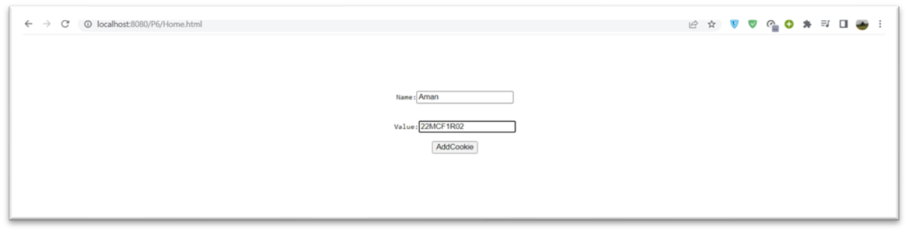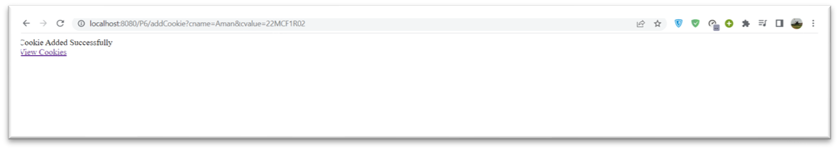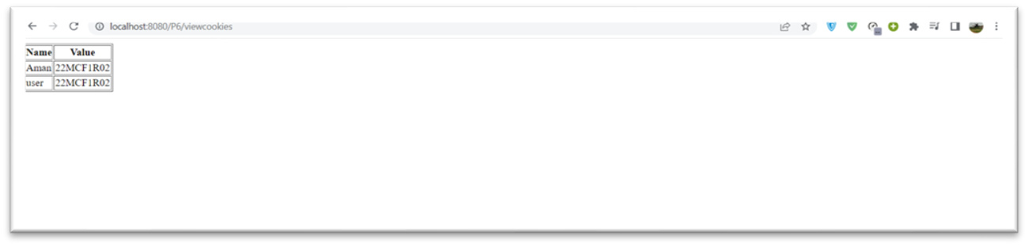

**7. Write a Servlet program that displays current date and time. Your servlt should**

**also indicate the number of times it has been assessed since it has been loaded.**

**Code**

**.java**

import javax.servlet.*;

import java.io.*;

public class date extends GenericServlet

{

private int hitCount;

public void init() { hitCount = 0;

}

public void service(ServletRequest req, ServletResponse res) throws IOException, ServletException

{

res.setContentType("text/html"); PrintWriter pw = res.getWriter(); hitCount++; java.util.Date date = new java.util.Date(); pw.println("<h2>Total Number of Hits:"+hitCount+"\n"); pw.println("<h2>"+"Current Date & Time: "

+date.toString()+"</h2>"); pw.close();

}

}

# .xml

<?xml version="1.0"?>

<web-app>

<servlet>

<servlet-name>calendar</servlet-name>

<servlet-class>date</servlet-class>

</servlet>

<servlet-mapping>

<servlet-name>calendar</servlet-name>

<url-pattern>/time</url-pattern>

</servlet-mapping>

</web-app>

# Output

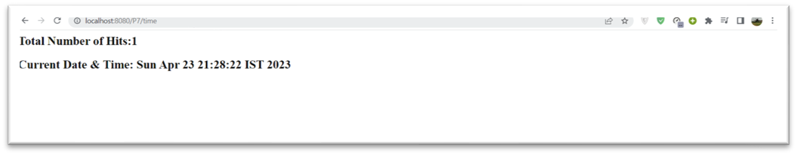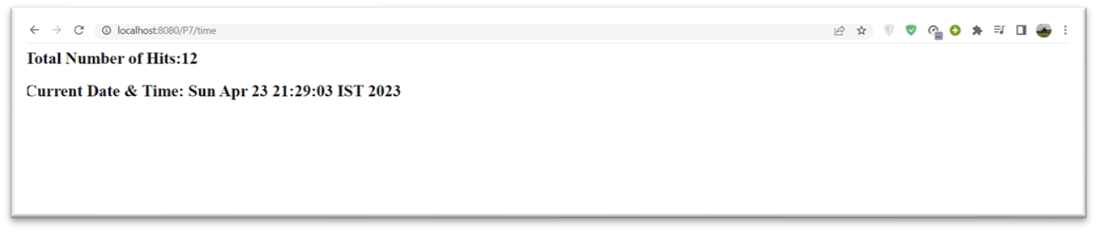

**8. Write a Servlet program to track the session using URL rewriting.**

**Code**

# .html

|  |
| --- |
| <html>  <body>  <form action="servlet1">  Name:<input type="text" name="userName" /><br />  <input type="submit" value="submit" /> </form>  </body>  </html> |

**.java**

# First

|  |
| --- |
| import java.io.*; import javax.servlet.*; import javax.servlet.http.*; import java.io.*;  public class first extends HttpServlet {  public void doGet(HttpServletRequest request, HttpServletResponse  response) { try { |

response.setContentType("text/html");

PrintWriter out = response.getWriter(); String n = request.getParameter("userName"); out.print("Welcome " + n); out.print("<a href='servlet2?uname=" + n + "'>visit</a>"); out.close(); } catch (Exception e) {

System.out.println(e);

}

}

}

# Second

|  |
| --- |
| import javax.servlet.http.*; import javax.servlet.*; import java.io.*;  public class second extends HttpServlet {  public void doGet(HttpServletRequest request, HttpServletResponse  response) { try {  response.setContentType("text/html"); PrintWriter out = response.getWriter(); String n = request.getParameter("uname"); out.print("Hello " + n); out.close();  } catch (Exception e) {  System.out.println(e);  }  }  } |

# .xml

<web-app>

<servlet>

<servlet-name>s1</servlet-name>

<servlet-class>first</servlet-class>

</servlet>

<servlet-mapping>

<servlet-name>s1</servlet-name>

<url-pattern>/servlet1</url-pattern>

</servlet-mapping>

<servlet>

<servlet-name>s2</servlet-name>

<servlet-class>second</servlet-class>

</servlet>

<servlet-mapping>

<servlet-name>s2</servlet-name>

<url-pattern>/servlet2</url-pattern>

</servlet-mapping>

</web-app>

**O**

**utput**

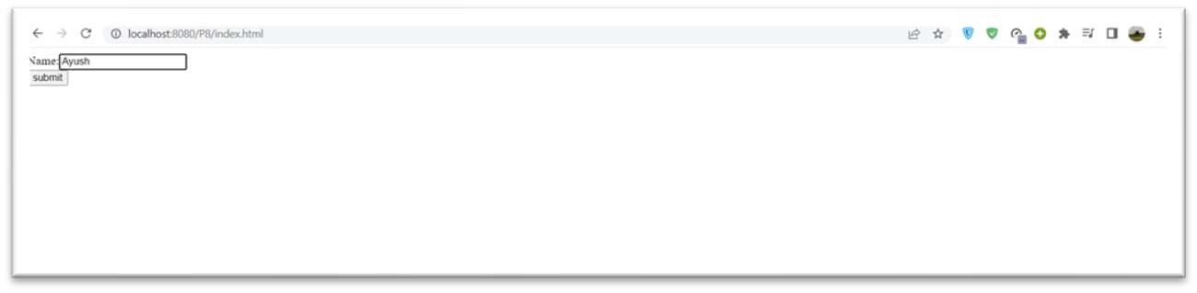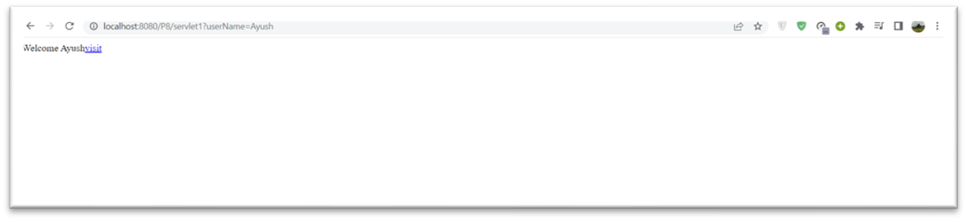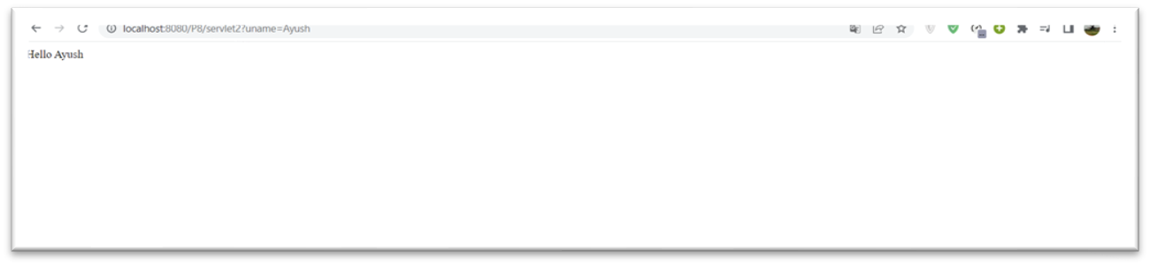

**9. Write a session tracking program in Servlet by using Hidden Form Fields.**

**Code**

# .html

<html>

<body>

<form action="servlet1">

Name:<input type="text" name="userName" /><br />

<input type="submit" value="submit" />

</form>

</body>

</html>

**.java**

# First

|  |
| --- |
| import java.io.*; import javax.servlet.*; import javax.servlet.http.*;  public class first extends HttpServlet {  public void doGet(HttpServletRequest request, HttpServletResponse  response) { try {  response.setContentType("text/html");  PrintWriter out = response.getWriter(); String n = request.getParameter("userName"); out.print("Welcome " + n); out.print("<form action='servlet2'>"); out.print("<input type='hidden' name='uname' value='" + n +  "'>");  out.print("<input type='submit' value='go'>"); out.print("</form>"); out.close();  } catch (Exception e) {  System.out.println(e);  }  }  } |

# Second

|  |
| --- |
| import javax.servlet.http.*; import javax.servlet.*; import java.io.*;  public class second extends HttpServlet {  public void doGet(HttpServletRequest request, HttpServletResponse  response) { try {  response.setContentType("text/html"); PrintWriter out = response.getWriter(); |

String n = request.getParameter("uname");

out.print("Hello " + n); out.close(); } catch (Exception e) {

System.out.println(e);

}

}

}

# .xml

<web-app>

<servlet>

<servlet-name>s1</servlet-name>

<servlet-class>first</servlet-class>

</servlet>

<servlet-mapping>

<servlet-name>s1</servlet-name>

<url-pattern>/servlet1</url-pattern>

</servlet-mapping>

<servlet>

<servlet-name>s2</servlet-name>

<servlet-class>second</servlet-class>

</servlet>

<servlet-mapping>

<servlet-name>s2</servlet-name>

<url-pattern>/servlet2</url-pattern>

</servlet-mapping>

</web-app>

**O**

**utput**

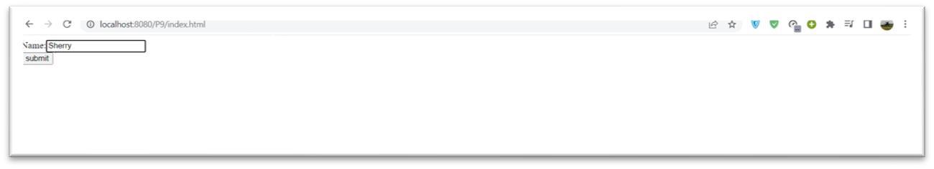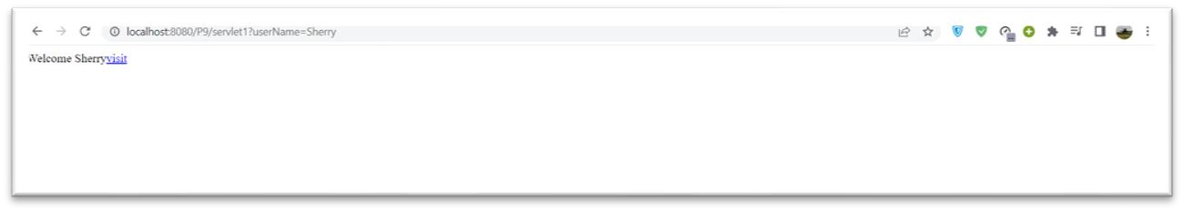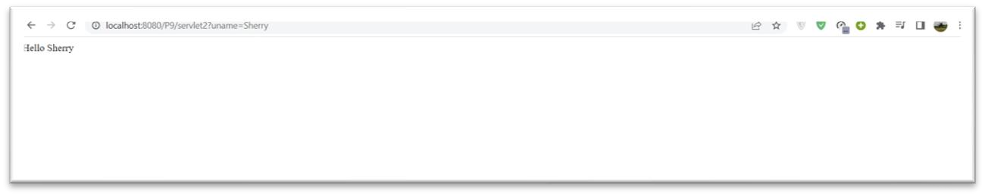

**10. Write a Servlet program to handle session by using HttpSession interface.**

**Code**

# .html

<html><body>

<form action="servlet1">

Name:<input type="text" name="userName"/><br/>

<input type="submit" value="go"/>

</form>

</body></html>

**.java**

# firstservlet

|  |
| --- |
| import java.io.*; import javax.servlet.*; import javax.servlet.http.*;  public class FirstServlet extends HttpServlet  { public void doGet(HttpServletRequest request, HttpServletResponse response)  { try{ |

response.setContentType("text/html");

PrintWriter out = response.getWriter(); String n=request.getParameter("userName"); out.print("Welcome "+n+" ");

HttpSession session=request.getSession(); session.setAttribute("uname",n); out.print("<a href='servlet2'>visit</a>"); out.close();

}

catch(Exception e){

System.out.println(e);

}

}

}

# Secondservlet

|  |
| --- |
| import java.io.*; import javax.servlet.*; import javax.servlet.http.*; public class SecondServlet extends HttpServlet { public void doGet(HttpServletRequest request, HttpServletResponse  response) throws ServletException,IOException  {  response.setContentType("text/html");  PrintWriter out = response.getWriter();  HttpSession session=request.getSession(false); String n=(String)session.getAttribute("uname"); out.print("Hello "+n); out.close();  }  } |

# .xml

<web-app>

<servlet>

<servlet-name>s1</servlet-name>

<servlet-class>FirstServlet</servlet-class>

</servlet>

<servlet-mapping>

<servlet-name>s1</servlet-name>

<url-pattern>/servlet1</url-pattern>

</servlet-mapping>

<servlet>

<servlet-name>s2</servlet-name>

<servlet-class>SecondServlet</servlet-class>

</servlet>

<servlet-mapping>

<servlet-name>s2</servlet-name>

<url-pattern>/servlet2</url-pattern>

</servlet-mapping>

</web-app>

**O**

**utput**

